PART A

(PART A : TO BE REFFERED BY STUDENTS)

**Experiment No.02**

Implementation of basic design interfaces

**A.1 Aim:**

1. Evaluate interaction rules by preforming tasks using virtual HCI lab.

1. Apply suitable web-based technology to implement web page design interfaces using following concepts
   1. Tables
   2. Colors
   3. Icon

iv. Where and what things should be placed

**A.2 Prerequisite:**

Students should have knowledge about Fitts law to understand other laws

Understanding of basic knowledge of HTML and CSS

**A.3 Outcome:**

**After successful completion of this experiment students will be able to**

1. You can apply Law in designing and placing widgets on computer interface.

2. Create a website

3. Apply bad and good interface on a website

**A.4 Theory:**

Design a bad interface of any website by misplacing the following things:

• Colors

• Icon

• Where and what things should be placed etc.

**A.5. Procedure:**

**Task I :**

Perform following activities **thrice** to plot graph

* Go to: <https://www.iitg.ac.in/cseweb/vlab/creative-design-prototyping/Fitts_simulator.html>

follow the Procedure , plot a graph for time taken by whole process and analyze it by giving your user experience.

* Go to <https://www.iitg.ac.in/cseweb/vlab/creative-design-prototyping/webers_simulator.html>

follow the instruction ,record the reading and plot graph. analyze it by giving your user experience.

* Go to <https://www.iitg.ac.in/cseweb/vlab/creative-design-prototyping/Hick_simulator.html>

follow instructions, calculate RT plot graph . analyze it by giving your user experience.

**Task II**

1. Explore any website and design two linked webpages of similar website using (WordPress or HTML/CSS) which includes
   * **Visibility of System Status**
   * **Consistency**
   * **Recognition and Feedback**
2. Compare your designed pages with existing website pages in terms of good and bad design interfaces (paste the screenshot wherever is applicable)
3. Observe the webpages and comment why bad interface is not required
4. Save and close the file and name it as **EXP2_ your Roll no.**

**(PART - B)**

(TO BE COMPLETED BY STUDENTS)

(Students must submit the soft copy as per following segments within two hours of the practical. The soft copy must be uploaded on the Blackboard or emailed to the concerned lab in charge faculties at the end of the practical in case there is no Black board access available)

|  |  |
| --- | --- |
| Roll.No. : | Name: |
| Sem/Year : | Batch: |
| Date of Experiment : | Date of Submission: |
| Grade -- |  |

**B.1: Input and Output:**

**Task 1**

* Add your graphs here with analysis

**Task 2**

* Take the screen shots of your designed webpages (two pages) and paste it

**Bad Design:**



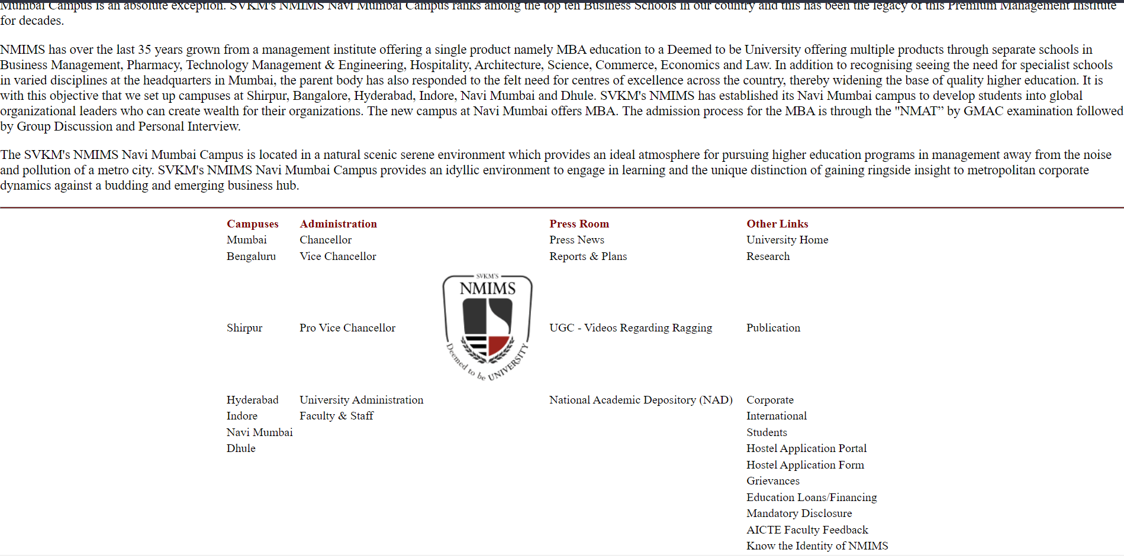

**Good Design:**



* Comparison of your webpage with existing webpages in terms of good and bad designing interface

The Bad Design had no order in which data is displayed. Footer at the bottom has no meaning and arrangement and the links on it redirect to error page. There is no such specification stating that the text has a link attached to it. In the header part where all the links and dropdowns for the navigation are to be placed, the cursor turns to a click pointer, but no feedback is received on clicking.

In the good design, there are animations and color that are soothing to the eye. All the information is orderly mentioned. The navigation bar follows towards the end of page so that the user can have navigating guidance all the time. In the contact section if any data field is empty or any data is wrongly given it gives an error while submitting. The headers in navigation leads to respective section of the website making the navigaton much easier and s,mooth.

**B.2: Observations and Learning’s:**

(Students are expected to comment on the output obtained with clear observations and learning for each task/ sub part assigned)

**B.3: Conclusion:**

(Students must write the conclusion as per the attainment of individual outcome listed above and learning/observation noted in section B.2)